**NAME: P V NAVI KISHORE**

**REG.NO.: 192111220**

**CODE: CSA1366**

**EXPERIEMNT: 6**

**AIM:** To design TM Simulation for Palindrome W= ababa c.

**PROCEDURE:**

1. Select seven states and consider one as initial and another as final state.
2. Join the states using edges with directioons
3. Select the edges as INPUT and OUTPUT as a or b or c.
4. Give the input and start the simulation.

**DESIGN AND OUPTPUT:**

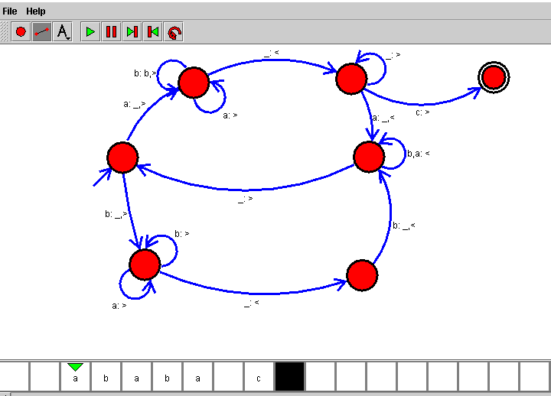

**RESULT:**

Therefore the designing of turing machine for the given input has been successfully created and stimulated.